# KNN Visualization

(Adapted from Dietterich) Refer to the training examples presented in the following table

|  |  |  |
| --- | --- | --- |
| X1 | X2 | Class |
| 2 | 4 | Positive (+) |
| 4 | 2 | Negative (*) |
| 4 | 4 | Positive (+) |
| 4 | 6 | Negative (*) |
| 6 | 2 | Positive (+) |
| 6 | 4 | Negative (*) |

a) Depict the above examples in a two-dimensional space (X1, X2), clarifying the class of each instance in the resulting chart.

Answer:

b) Illustrate the decision boundaries for the 1-nearest neighbour algorithm, utilizing standard Euclidean distance for determining the nearest neighbours. Here, a plus symbol represents a positive example, while a star symbol denotes a negative example.

Answer:

For the 1-nearest neighbour algorithm, we will find the nearest neighbor for each test point in the training data based on Euclidean distance.

Here are the steps to draw the decision boundaries:

1. Draw a dotted line connect two training points(A&B)
2. Find the midpoint of the dotted line (AB), and then draw a solid line (+AB) perpendicular to the dotted line through this midpoint.
3. This solid line(+AB) represents the decision boundaries between two points(A&B). As any test points on this line has the same distance between these two training points(A&B). Points on one side of the solid line will be classified as belonging to one class, while points on the other side will be classified as belonging to a different class.
4. Repeat step1-3 for each pair of training points, and then we can get the decision boundaries for the 1-nearest neighbour algorithm as follows.

**Positive class: Purple area Negative class: Orange area**.

c) Determine the classification of the point (8, 1) by the 1-nearest neighbour classifier.

Answer:

The point (8, 1), marked in blue, falls within the orange area. By determining its closest neighbor, we find that it is nearest to the point (6, 2), which belongs to the positive class. Therefore, the classification of the point (8, 1) is Positive.

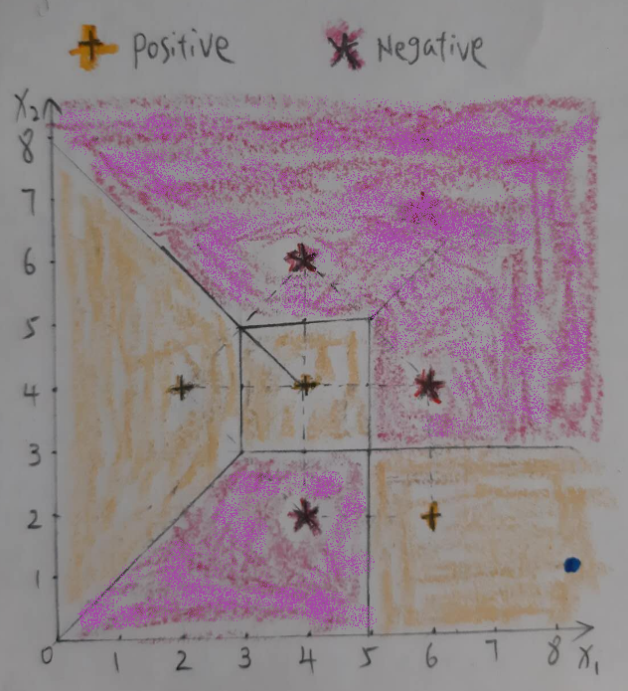

d) Identify how the classifier would categorize the point (8, 8).

Answer:

The point (8, 8), marked in green, falls within the purple area. By determining its closest neighbor, we find that it is nearest to the point (6, 4) and the point (4,6), which belong to the negative class. Therefore, the classification of the point (8, 8) is negative.

